Put this into chat message along with the product requirements document:

SESSION REQUEST: 1.1 Database Schema & Core Architecture
CURRENT STATUS:
- Joomla Version: 3.x or 4.x? (Please specify exact version)
- PHP Version: [Please specify]
- Database: MySQL/MariaDB [Please specify version]
- Previous Sessions Completed: None
SPECIFIC REQUIREMENTS: None
TESTING ENVIRONMENT READY: [Please confirm Yes/No]

SESSION 1.1: Database Schema & Core Architecture

Objectives:
- Create database tables with Joomla 6+ compatibility
- Build version detection and compatibility layer
- Create database abstraction adapter
- Build abstract search engine foundation

Files to be Created:

File 1: Database Installation SQL
File created by Deepseek (use VSCode to create the file)
Location: /sql/install.mysql.utf8.sql

File 2: Version Compatibility Checker
Location: /src/Compatibility/VersionCheck.php

File 3: Database Adapter
Location: /src/Database/Adapter.php

File 4: Abstract Search Engine
Location: /src/Search/AbstractSearchEngine.php

INSTALLATION INSTRUCTIONS

Step 1: Create Directory Structure
On your Joomla server, create these directories:
/administrator/components/com_ajaxsearch/
/components/com_ajaxsearch/
/modules/mod_ajaxsearch/
/plugins/system/ajaxsearch/
/plugins/content/ajaxsearch/

Step 2: Install Database
- Go to phpMyAdmin or your database management tool
- Select your Joomla database
- Run the SQL from File 1 (/sql/install.mysql.utf8.sql)
- Verify tables were created:
  - [prefix]_ajaxsearch_cache
  - [prefix]_ajaxsearch_sp_cache
  - [prefix]_ajaxsearch_analytics
  - [prefix]_ajaxsearch_config

Step 3: Create Component Structure
Create these files in /components/com_ajaxsearch/:
- Create directory: /components/com_ajaxsearch/src/
- Create subdirectories: Compatibility/, Database/, Search/
- Save File 2 as: /components/com_ajaxsearch/src/Compatibility/VersionCheck.php
- Save File 3 as: /components/com_ajaxsearch/src/Database/Adapter.php
- Save File 4 as: /components/com_ajaxsearch/src/Search/AbstractSearchEngine.php

Step 4: Test Version Detection
Create a test file: /components/com_ajaxsearch/test_version.php

Step 5: Run Test
- Access the test file via browser: yoursite.com/components/com_ajaxsearch/test_version.php
- Verify:
  - No PHP errors
  - Compatibility check shows all green
  - Database tables are reported as "Exists"
  - Correct charset detected

test_version.php did not work on my site. Deepseek wrote new test program test_dev.php this test did not work either.
Deepseek wrote a simple test program that did work and here are the results below:

https://phpstack-1208205-5933111.cloudwaysapps.com/components/com_ajaxsearch/test_final.php

https://phpstack-1208205-5933111.cloudwaysapps.com/components/com_ajaxsearch/simple_test.php

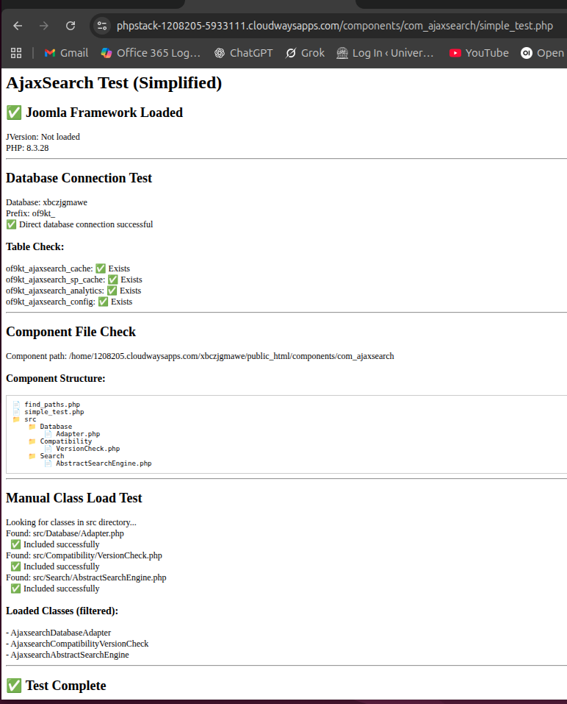

Step 6: Clean Up
- Delete the test file after testing
- Verify all files are in correct locations

TESTING CRITERIA FOR THIS SESSION
✅ Database Installation:
- All 4 tables created without errors
- Default configuration inserted
- Tables have correct indexes
✅ Version Detection:
- Correctly identifies Joomla version
- Returns proper compatibility status
- Detects UTF8MB4 support correctly
✅ Database Adapter:
- Connects to database successfully
- Returns correct charset/collation
- Table existence check works
- Query methods don't throw errors
✅ Abstract Search Engine:
- Class loads without errors
- Methods are properly defined
- No syntax errors

NEXT SESSION PREPARATION
Session 1.2: Basic Article Search Engine
- Will implement concrete article search class
- Create AJAX endpoint
- Add basic caching
- Create search model
What to prepare:
- Ensure Session 1.1 files are in place
- Test database connectivity
- Verify no PHP errors in current files
- Have sample articles in your Joomla for testing

